1. Agenda:
   1. Going to run the Products MS to check if ProductCreatedEvent was published to Kafka Broker Asynchronously.
2. 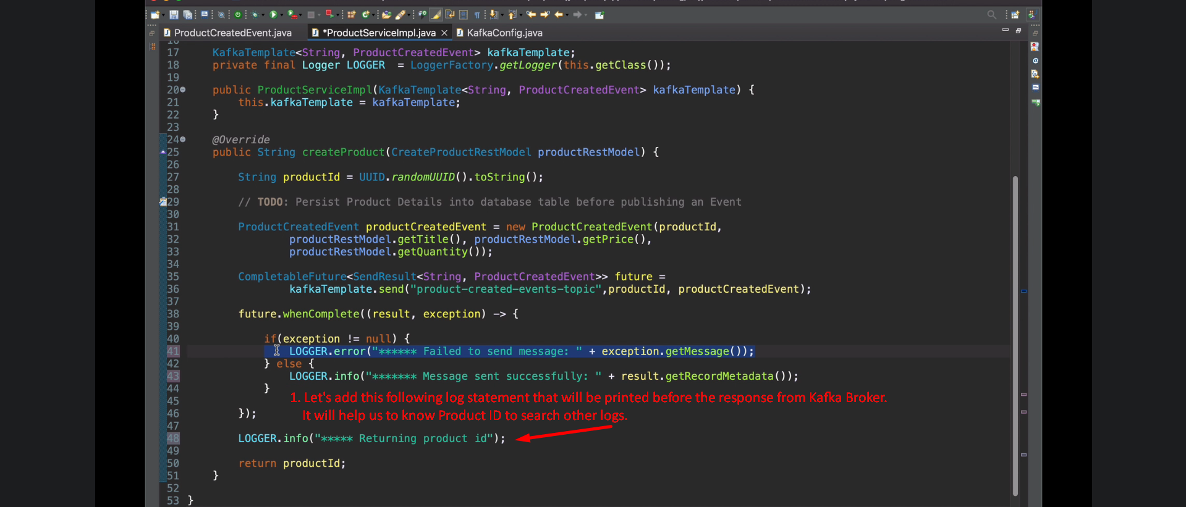
3. 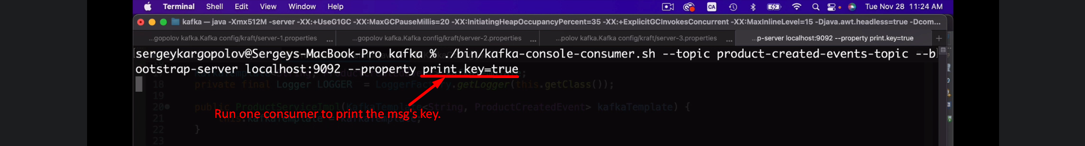
4. 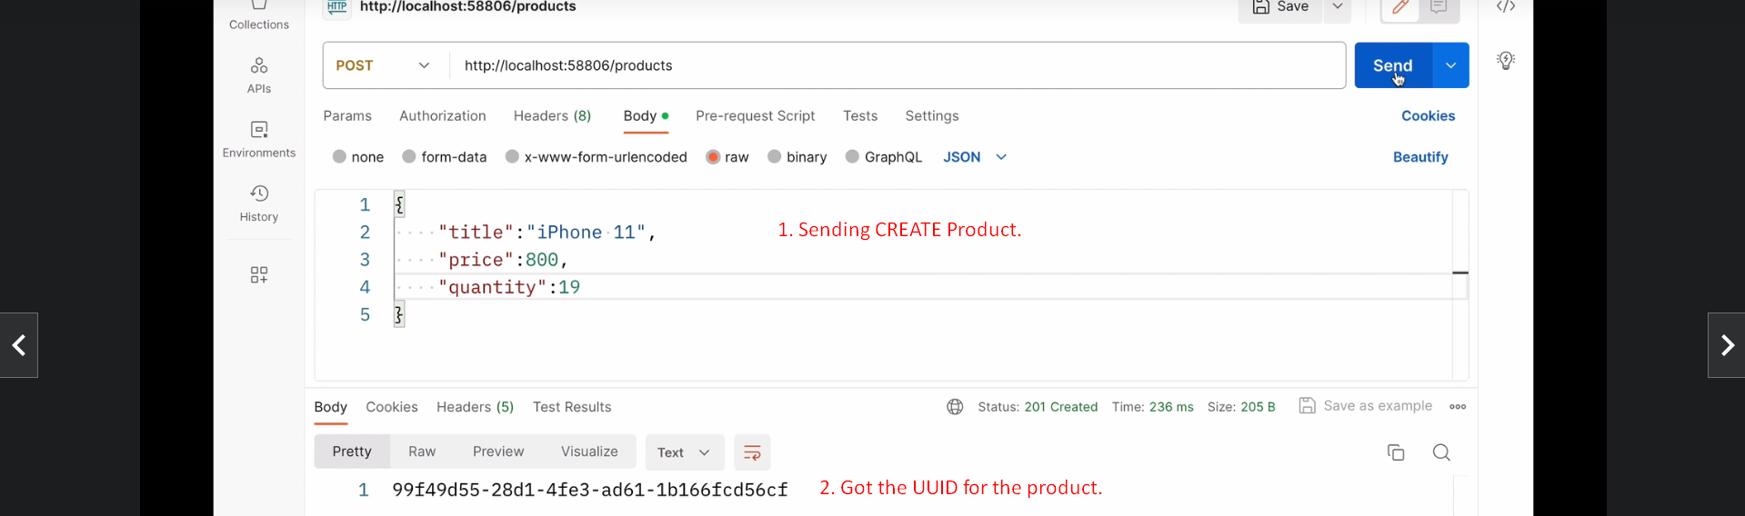
5. 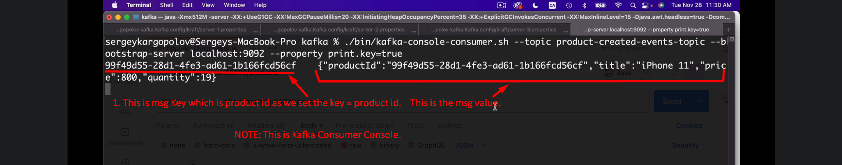
6. 